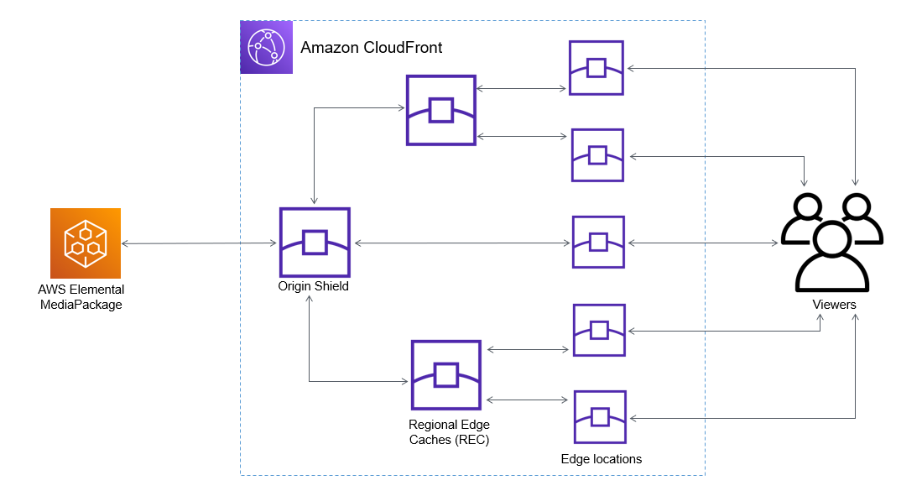 AWS-Project- Creating S3/Cloud front distribution for website content

Web page

visitor

Edge Location

Us-East-1

Cloud

Front

S3 Bucket

Origin-image-index.html

Us-East-1



AWS Cloud

For this project, I will be creating a CloudFront distribution using S3 and edge locations.

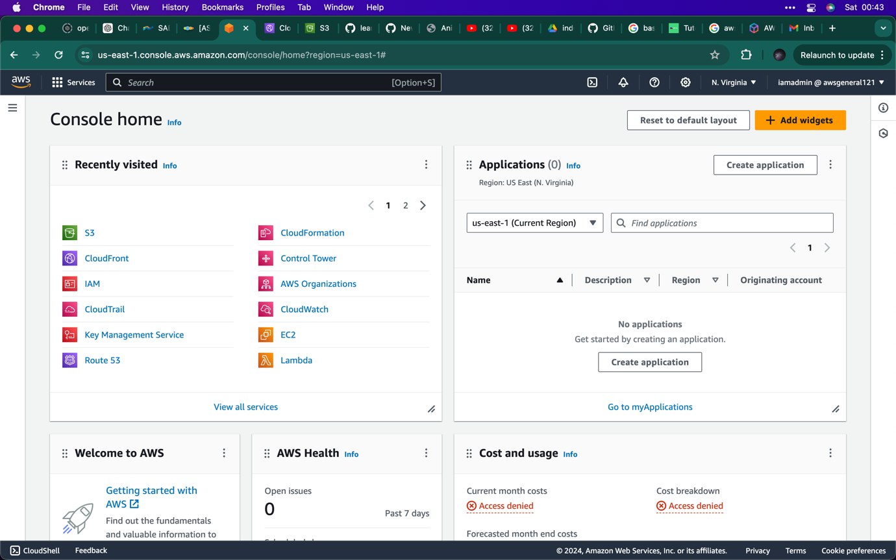

1. Navigate to the console page and click on the S3 application.

Note: S3 will be used to upload the files.

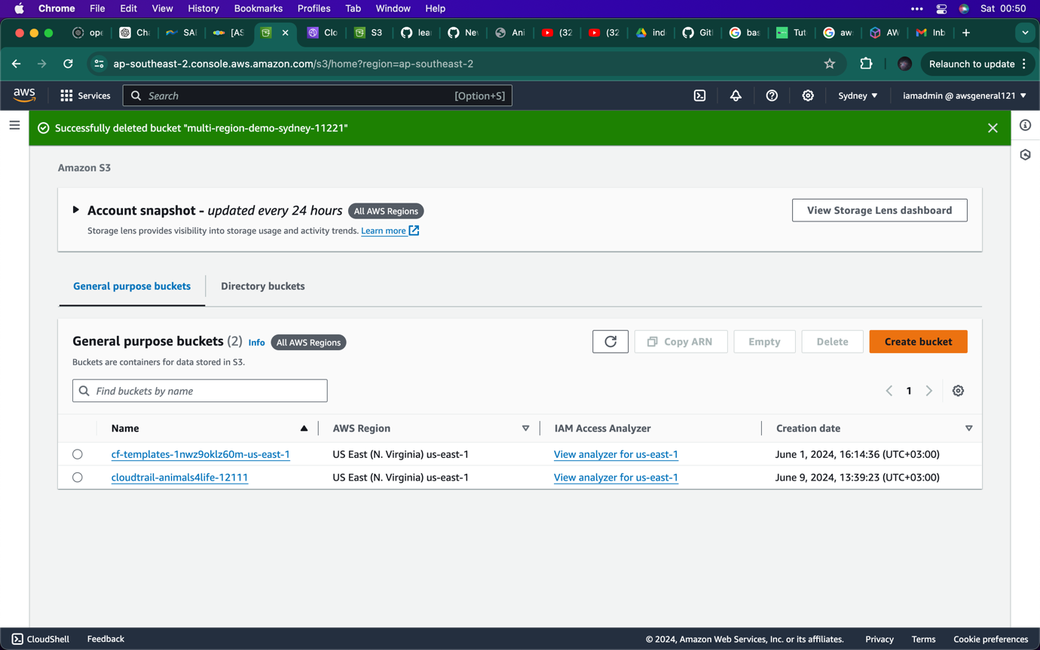

1. Click on create bucket

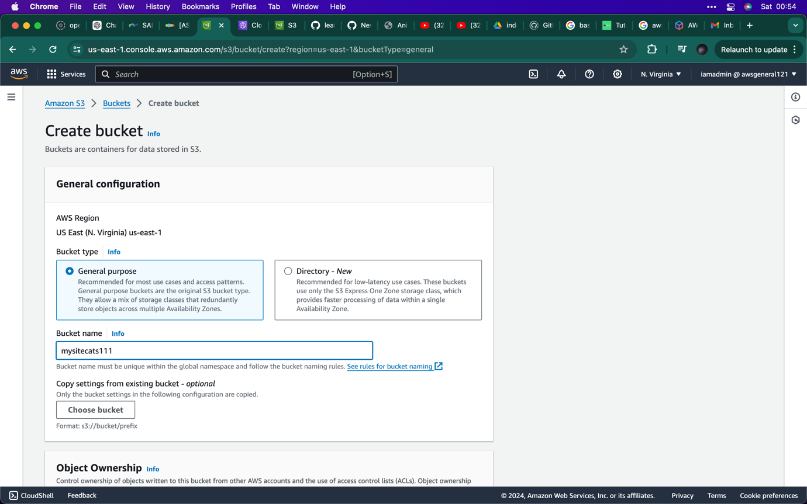

1. Write the name of the bucket
2. 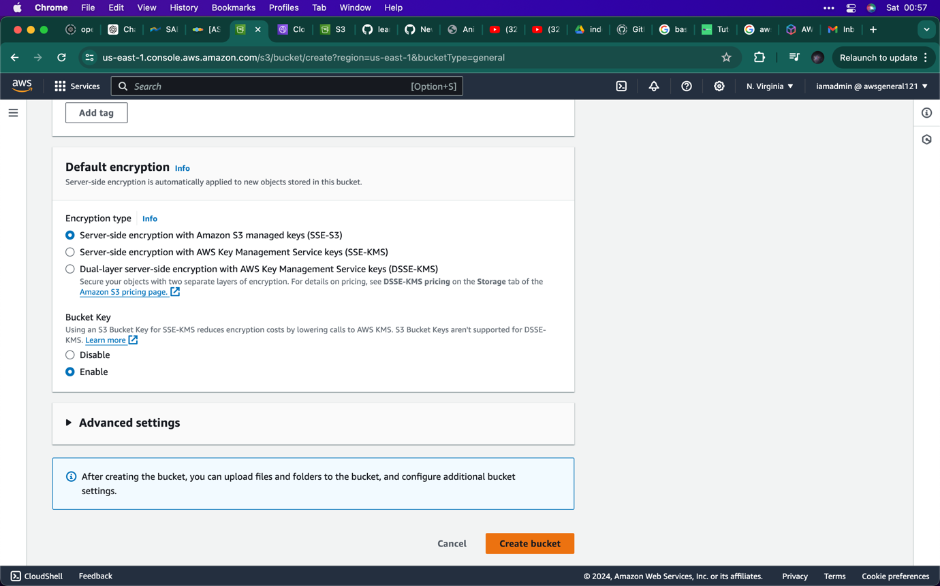click on create bucket
3. 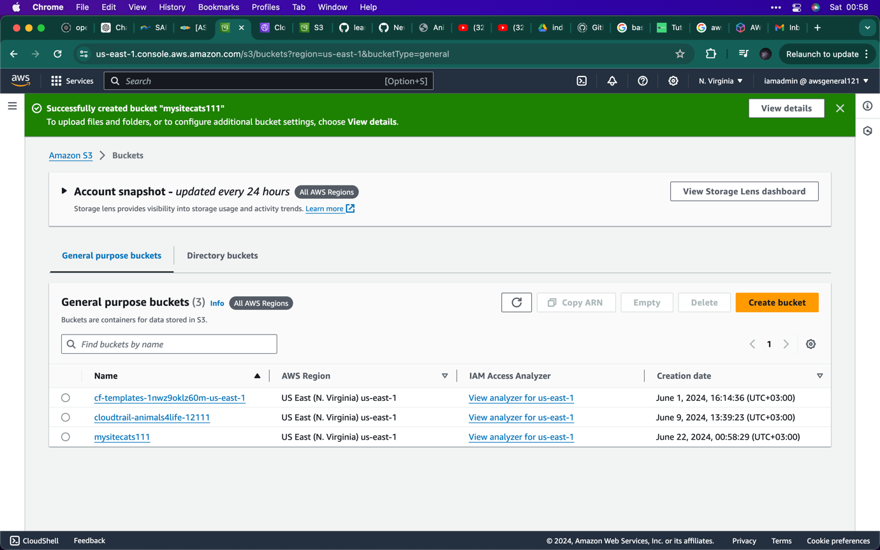your bucket should come up

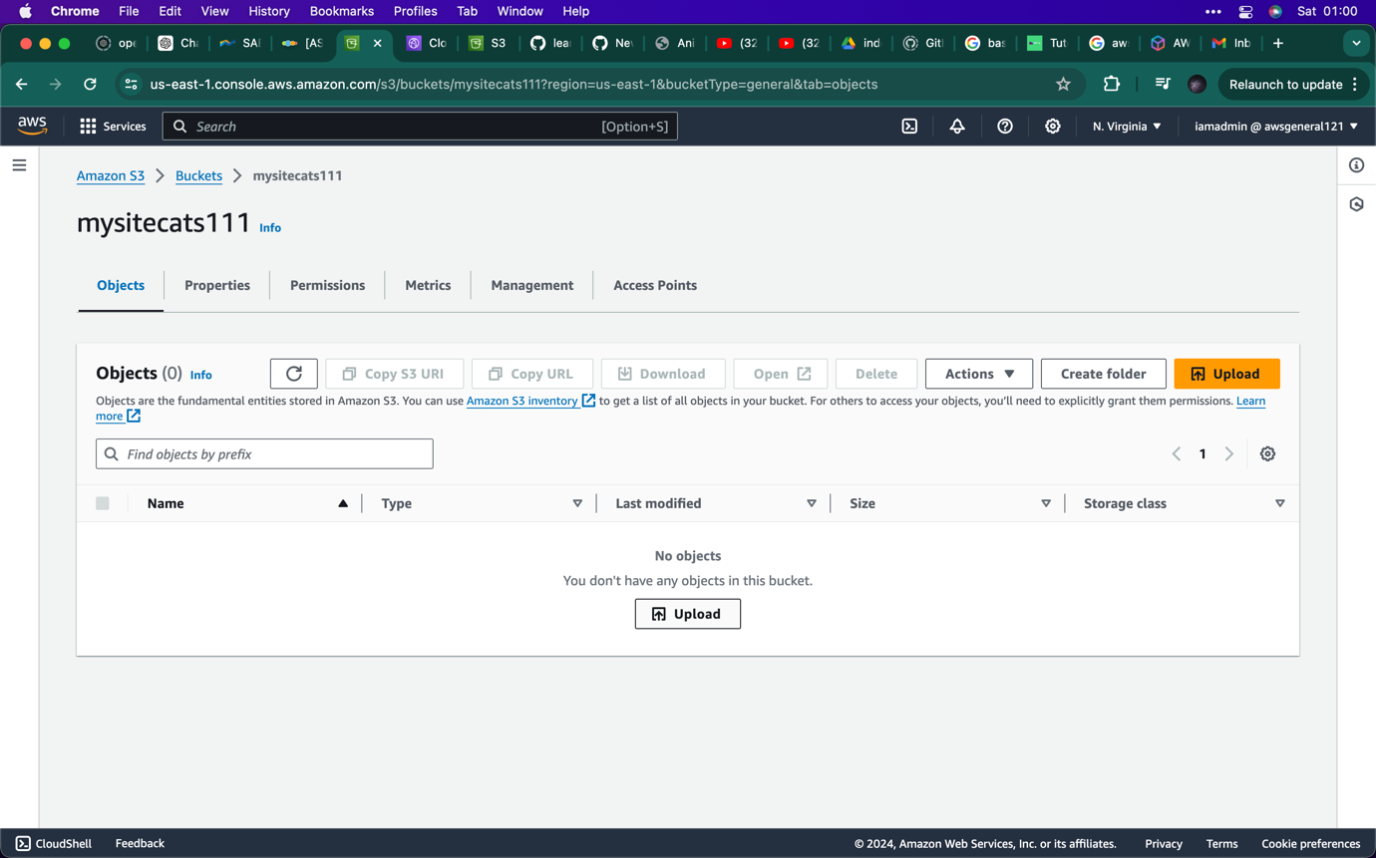Note: click on the bucket to upload your files.

1. Click on the upload button and upload the files

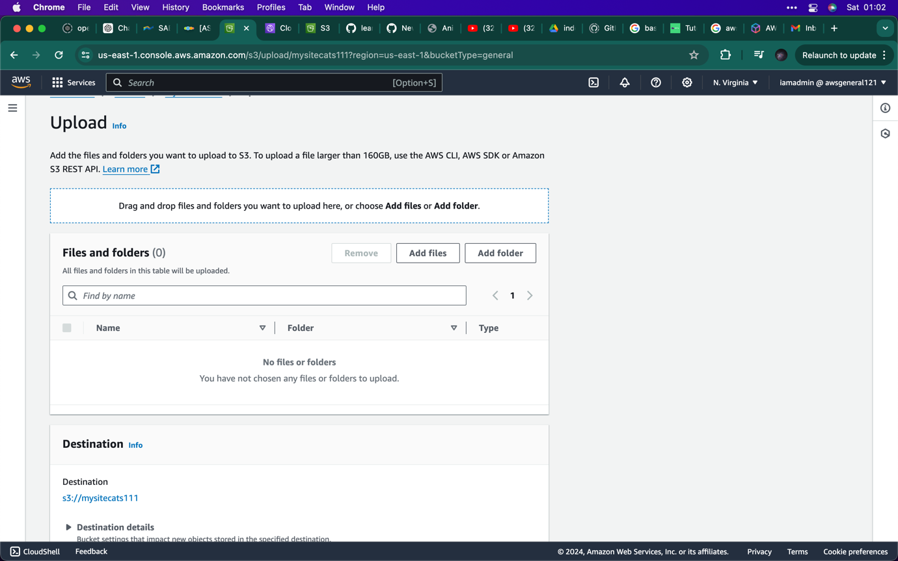

1. Click on the add file

Note: make sure you add the website html page

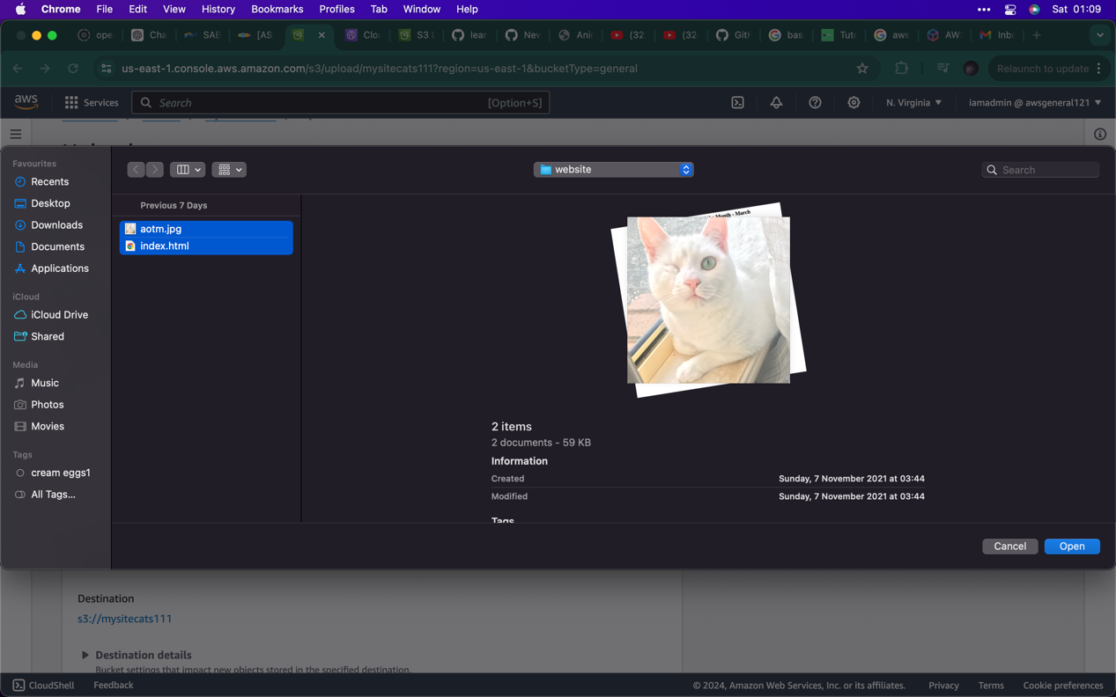

1. Select both files the image and the html file.
2. 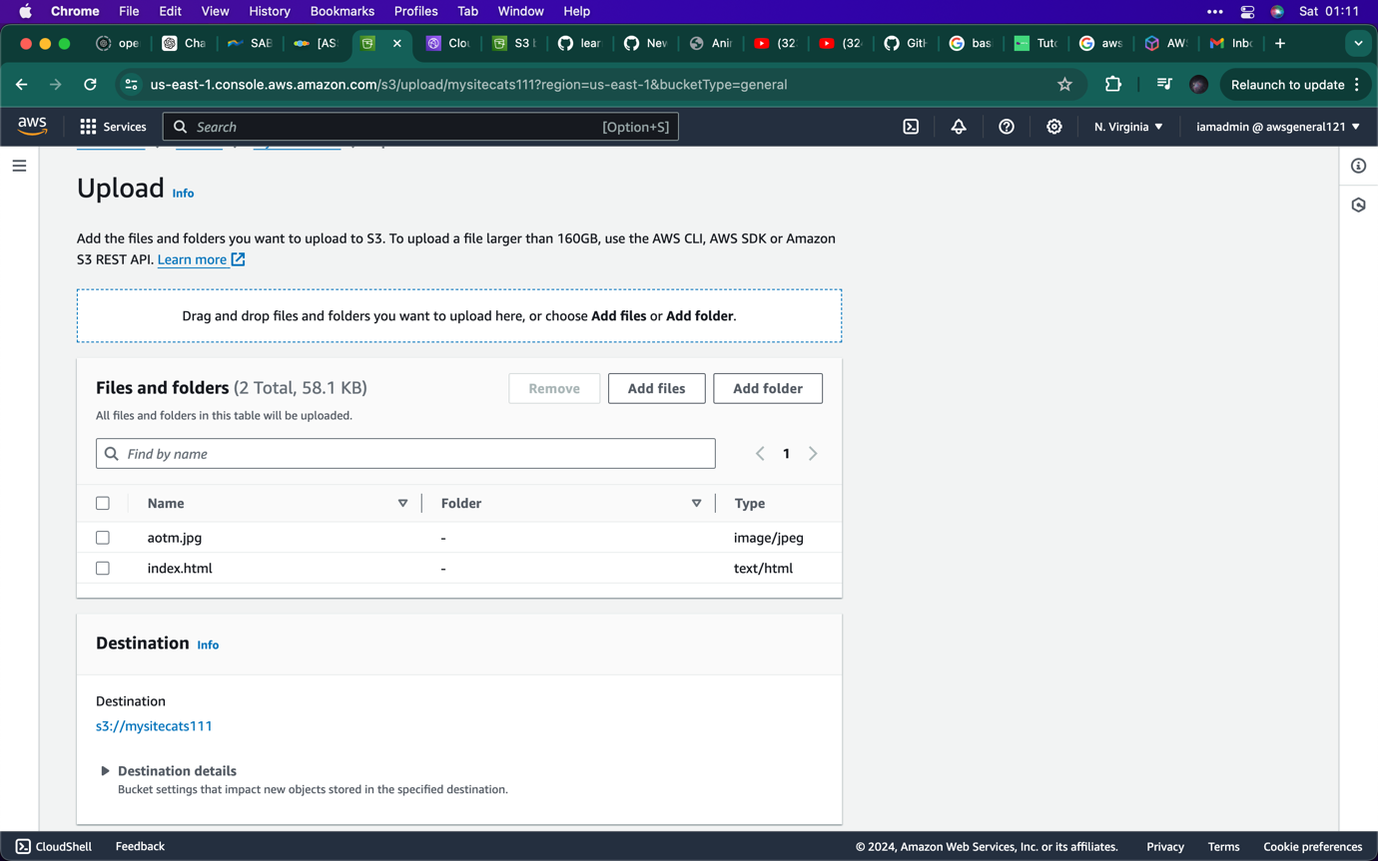as you can see both file are now inside the bucket

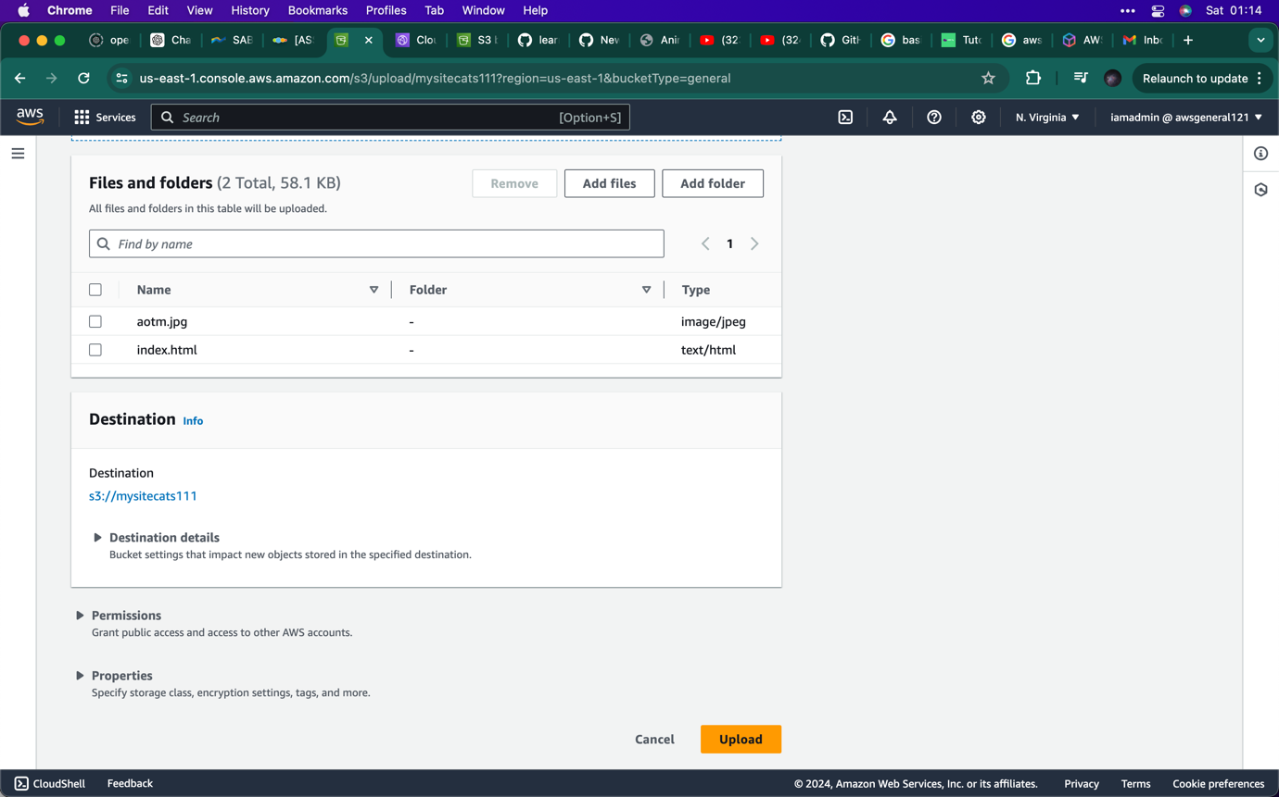Click on the upload button

1. Click on the upload button

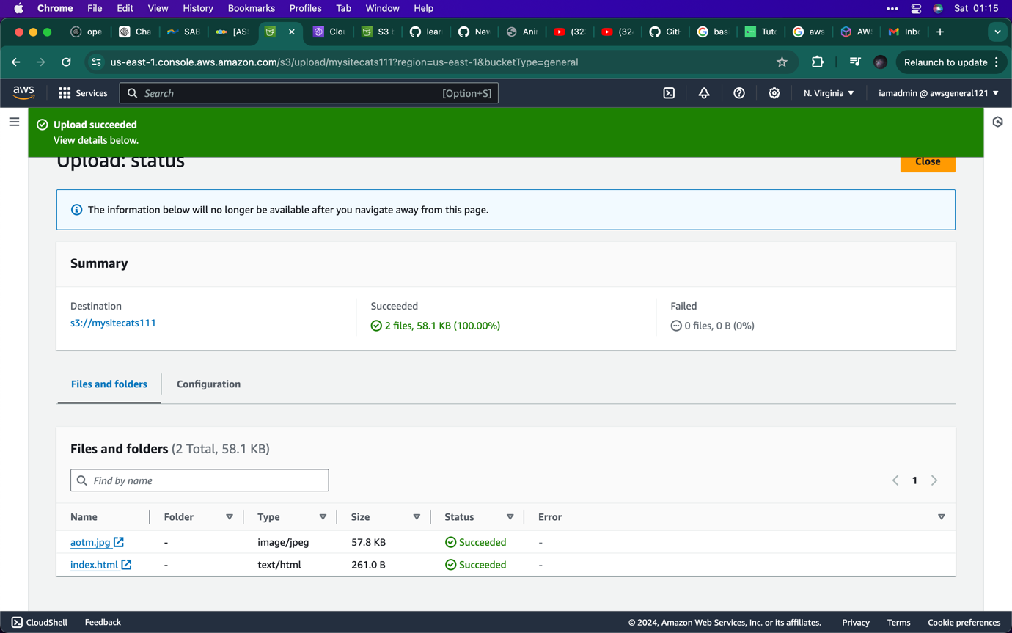

1. Now you can see both files have successfully been uploaded, click on close

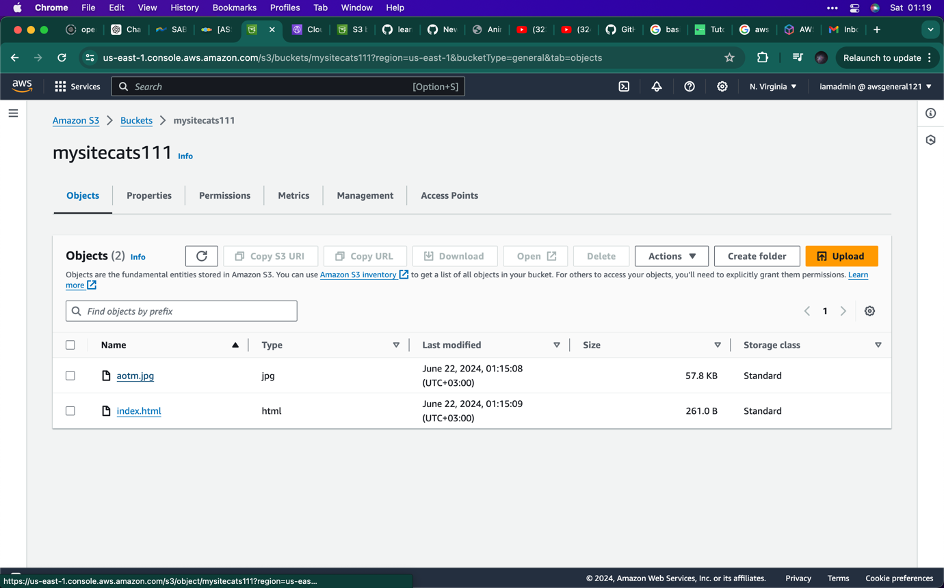Note: The image file is not accessible because the it is private

1. Click on the image file as seen above,

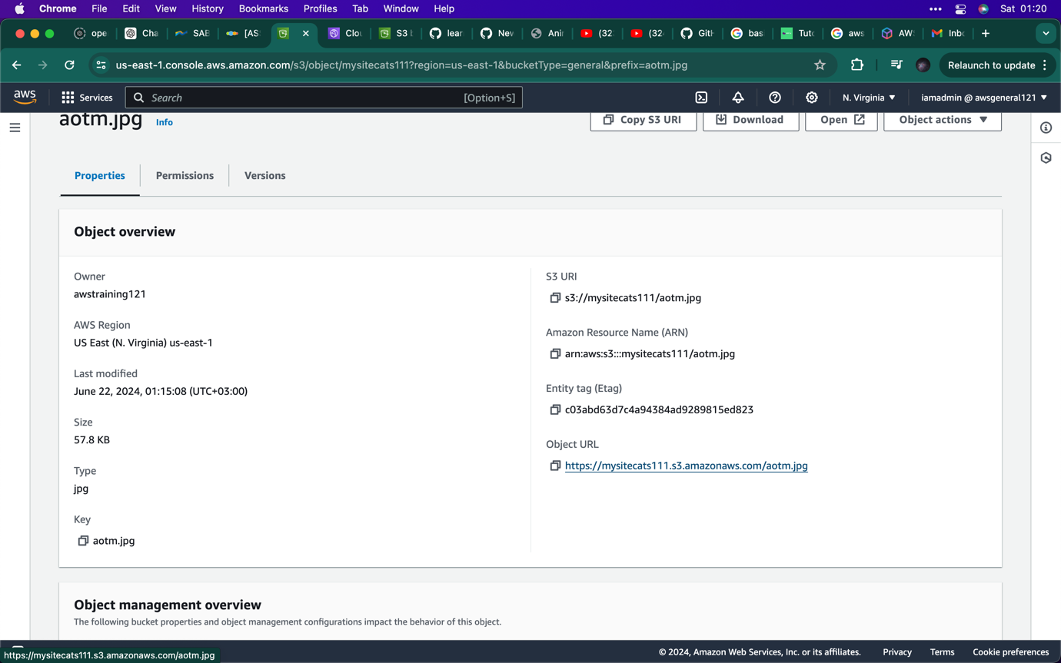

1. Remember the image file is private not public click on the object URL and you will see it returned with an error message

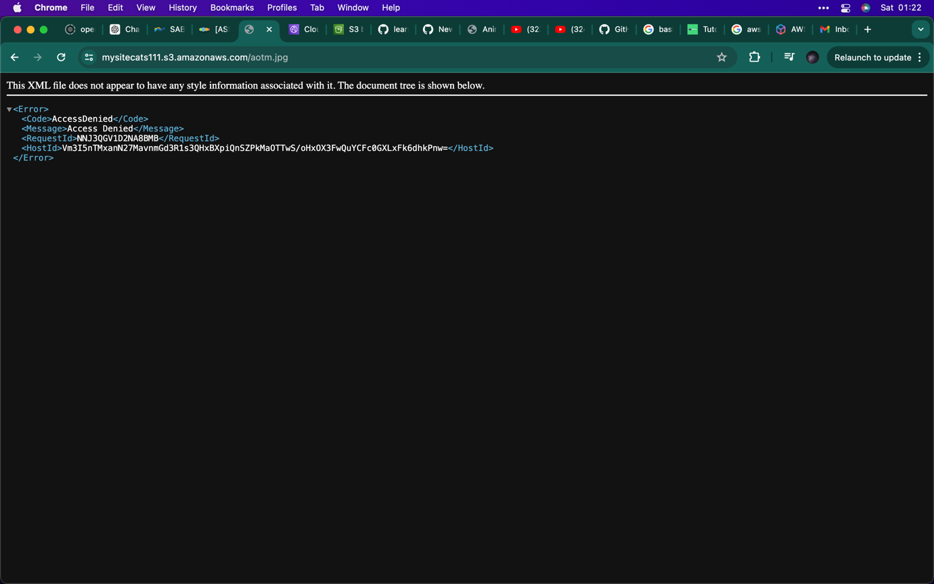

1. As mentioned above, this is the error message you will see.

Note: we want cloudfront to access the files so people can view them

1. you can get a temporary access by clicking on the button

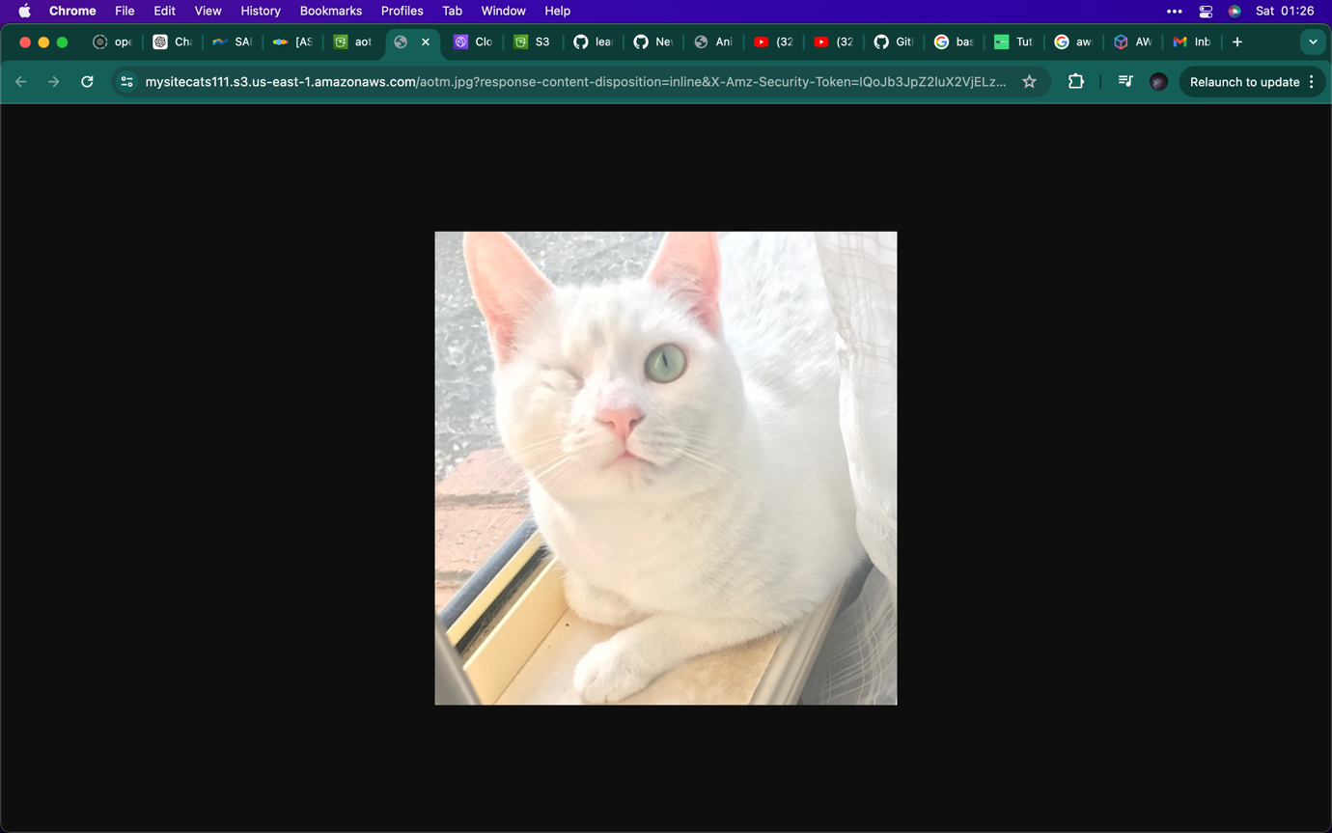

1. Once the open button is clicked this is the image in the file.

Note: I will now create cloudfront, remember this is a tool that will delivery the content as for this case the images etc..

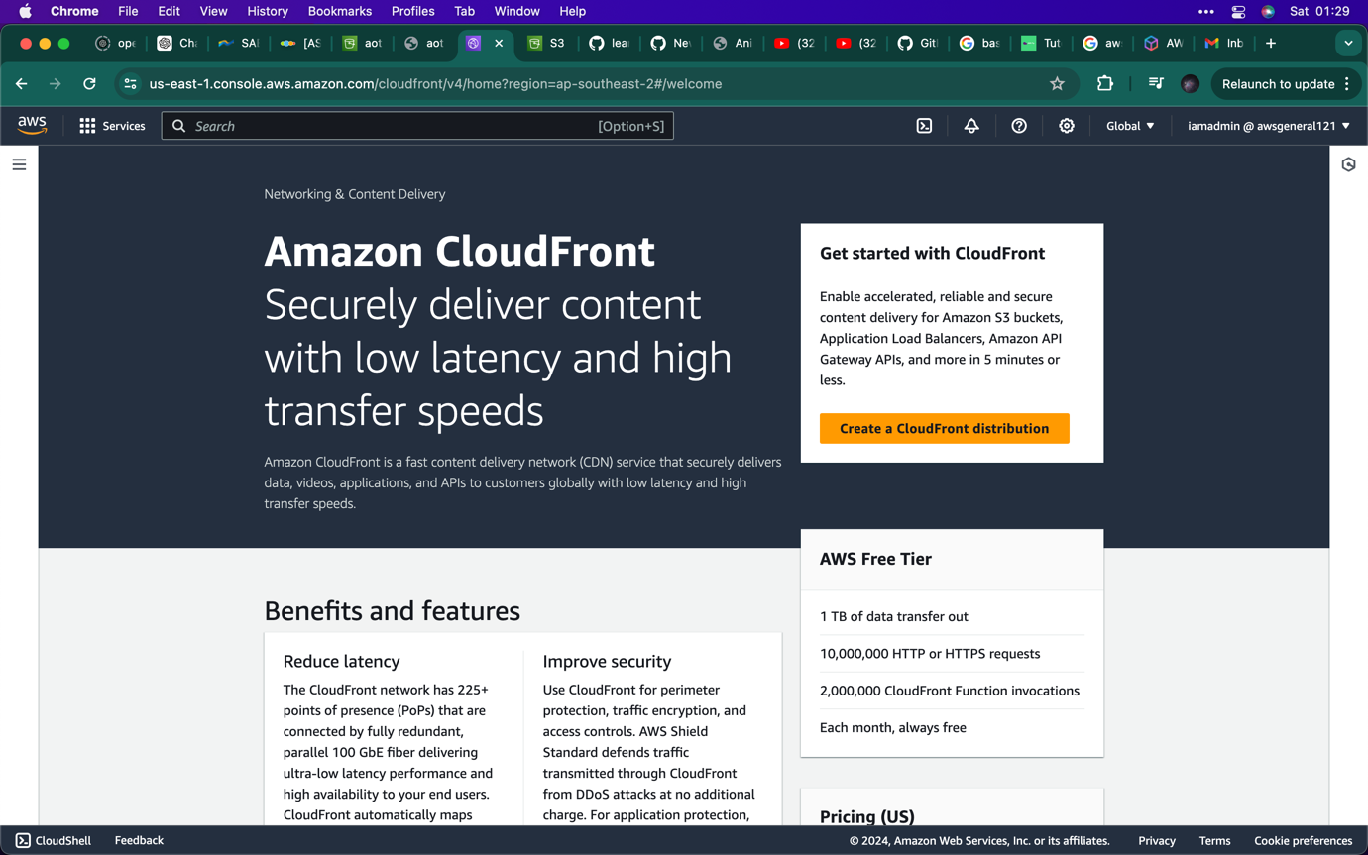

1. In the search bar type cloudfront, you should see this,
2. 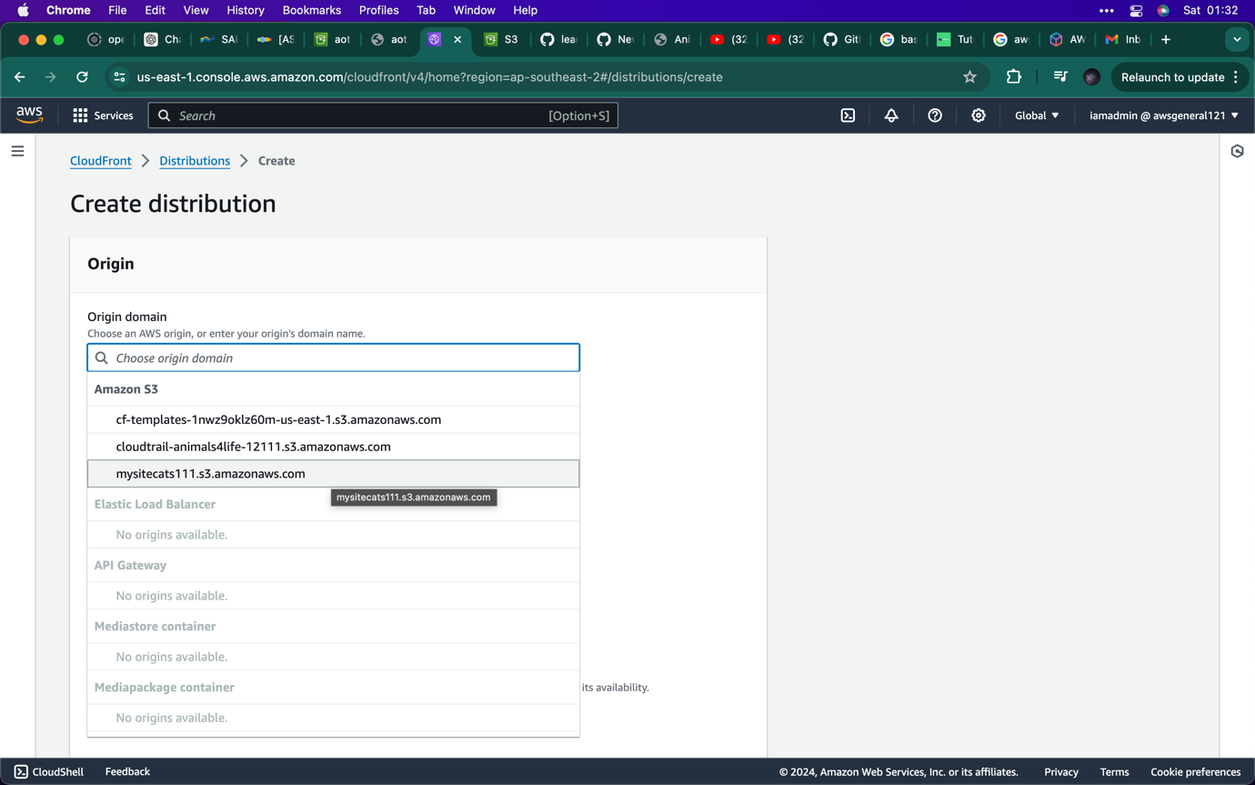click on create a cloudfront distribution.
3. In this section you will need to origin domain name. Remember if you go back to the architecture you will see that we created two objects inside the bucket. You can see the name of object, select it.
4. 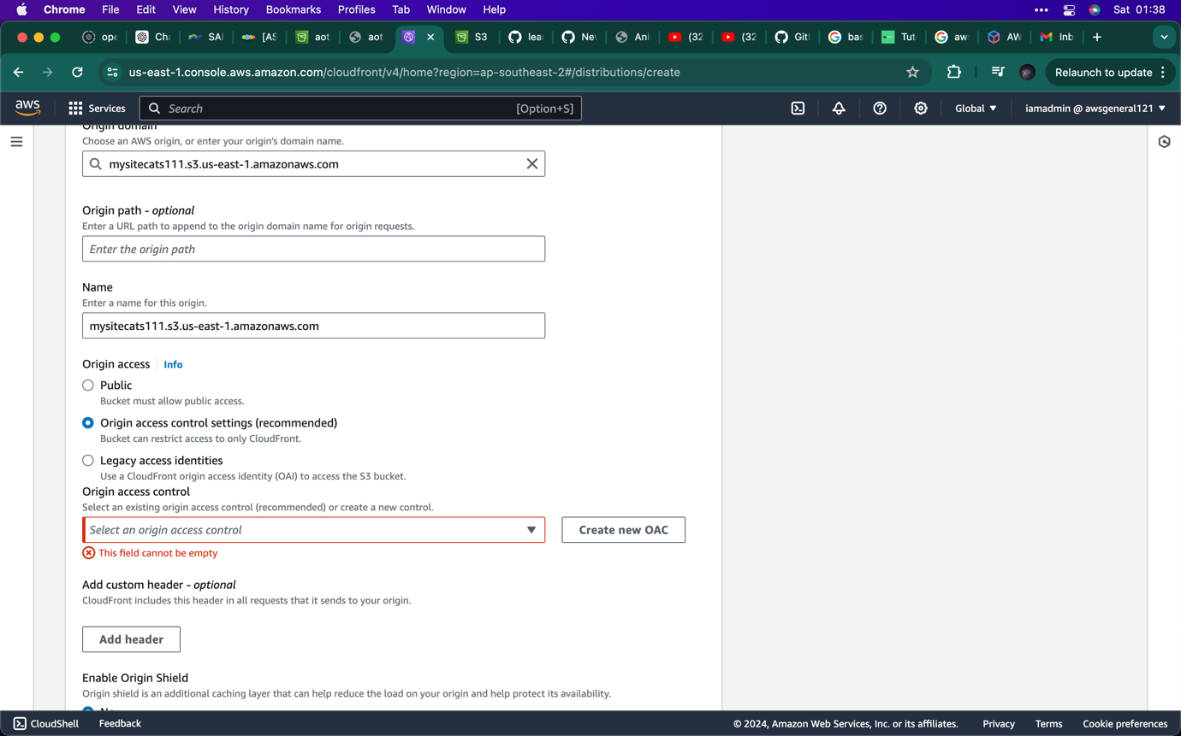select the recommended setting
5. Click on create OAC

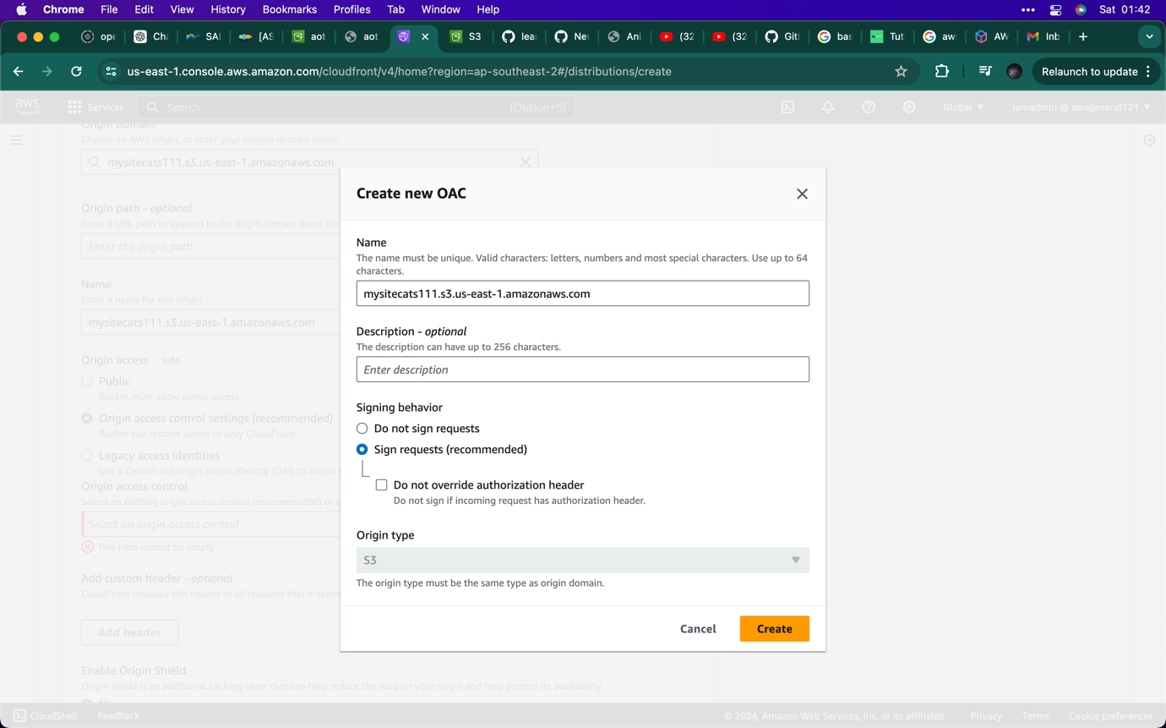

1. Click on create

Note: this action would give cloudfront access to retrieve files from S3.

1. 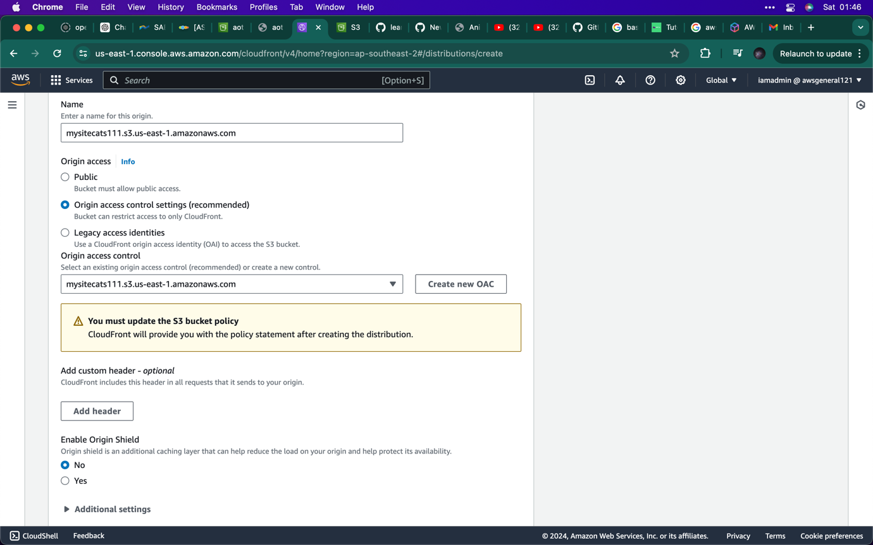now you will see this message pop up , you need a S3 bucket policy.

This is going to allow cloudfront IAM role, but cloudfront will generate this policy statement.

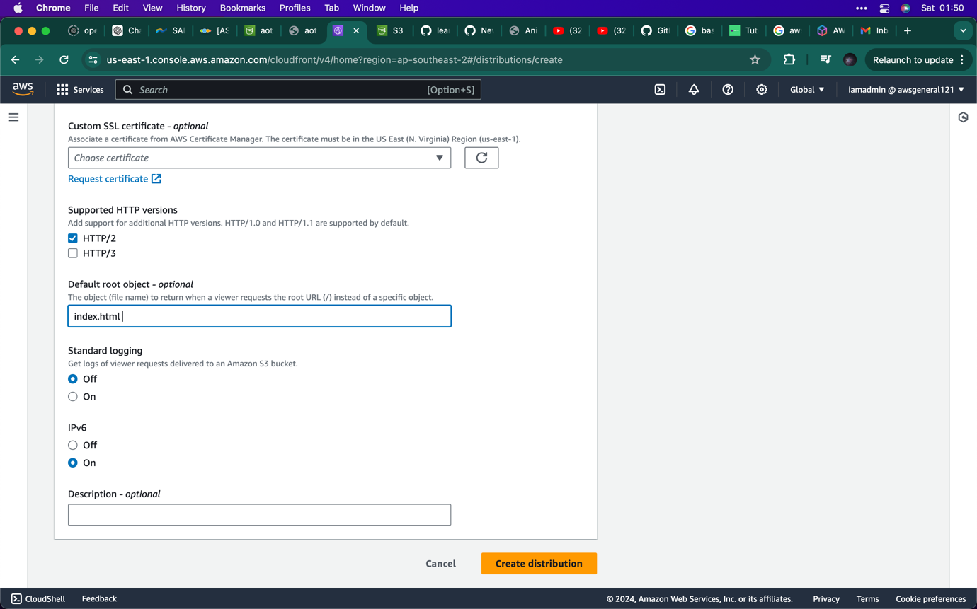

1. Enter the object name
2. Click on create distribution

Note: this action will return an image or whatever it maybe requests the root URL, remember this is retrieved from S3 bucket.

1. 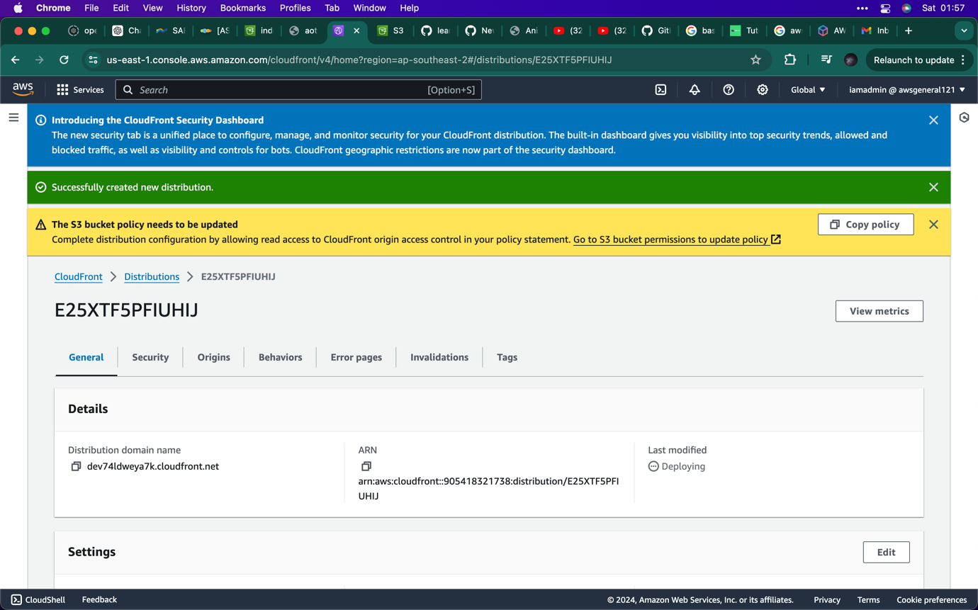Now you need to copy the S3 bucket policy
2. Click on S3 bucket link to paste the policy link

Note: if you need more info go to fig 23.

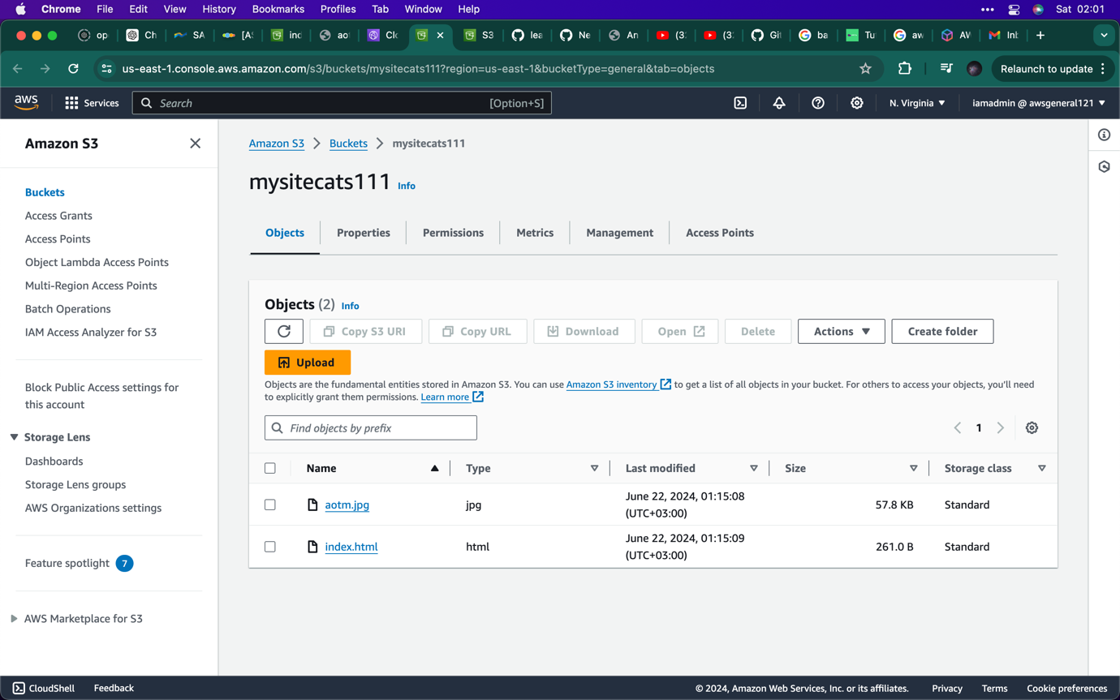

1. Now click on permission to paste in the policy

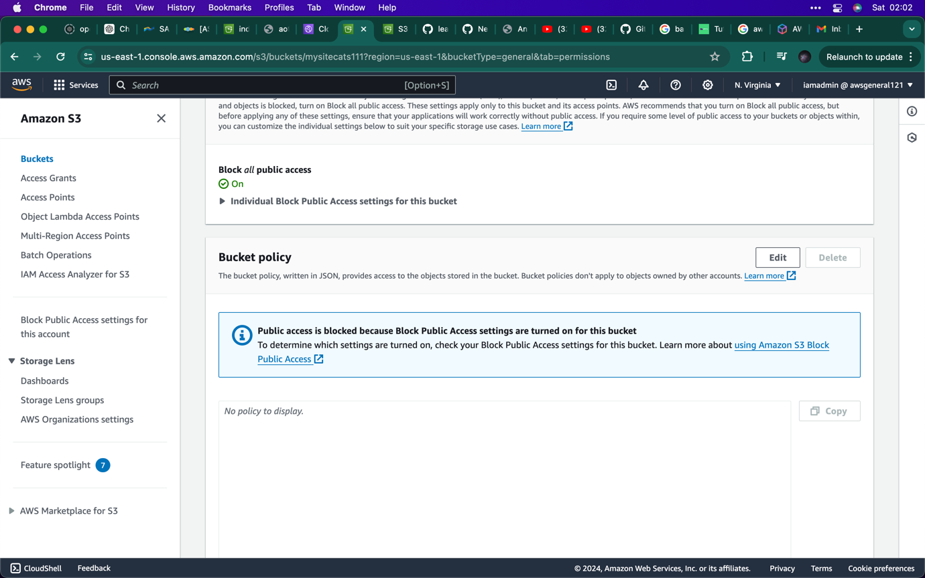

1. Click on edit

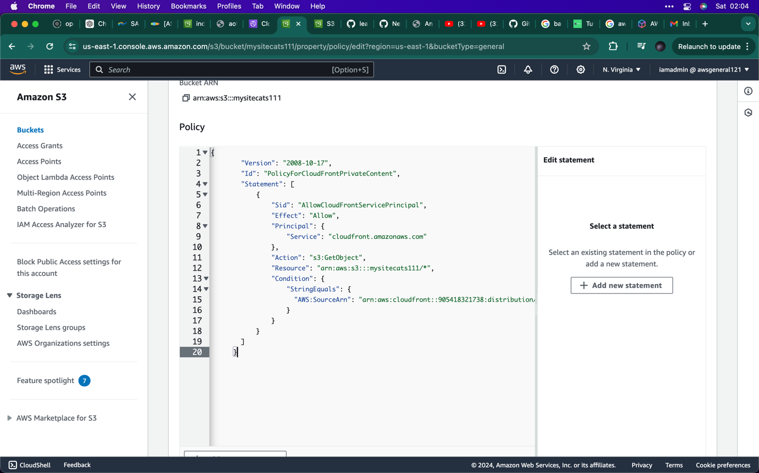

1. Now you can see the policy java code.
2. Click on saves changes

Note: this policy states that “allow” allowed cloudfront is "cloudfront.amazonaws.com" to read "Action": "s3:GetObject", from "Resource": "arn:aws:s3:::mysitecats111/*"

1. 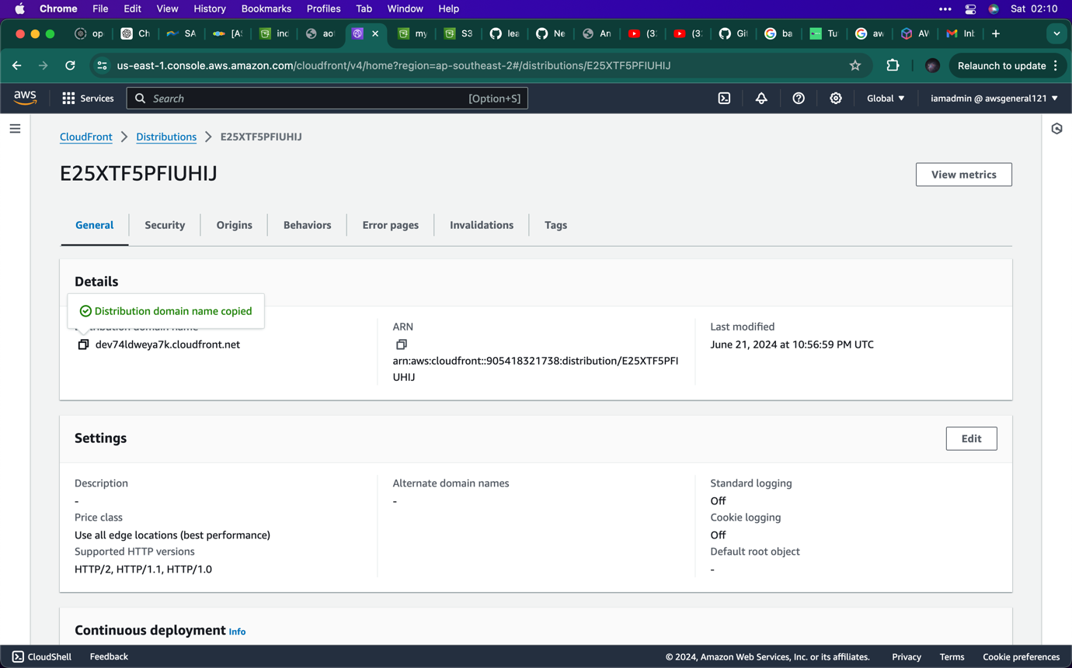In order to see if the domain name is working, click on link
2. Open a new tab window to paste the link.

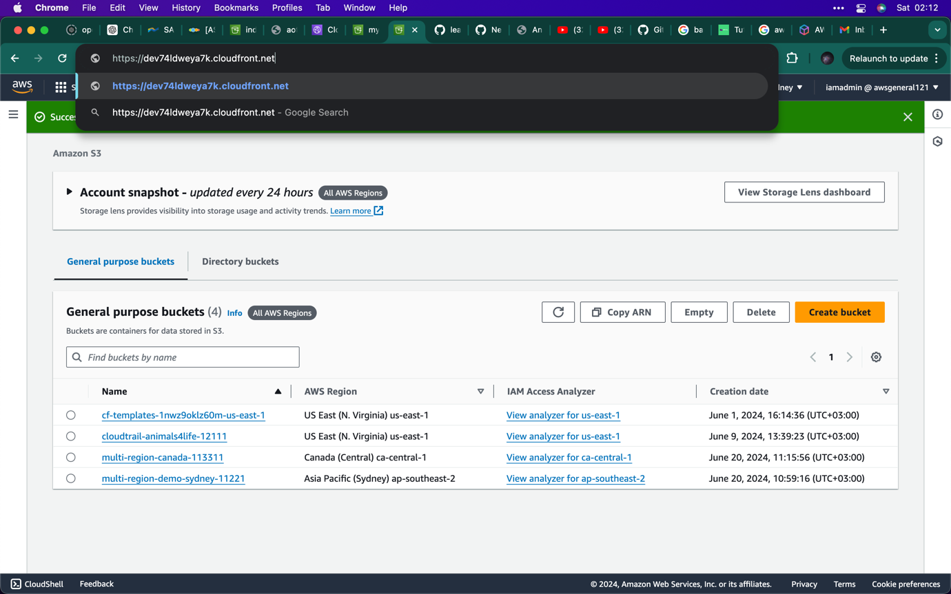

1. Above you can see the link , run it and see what appears.

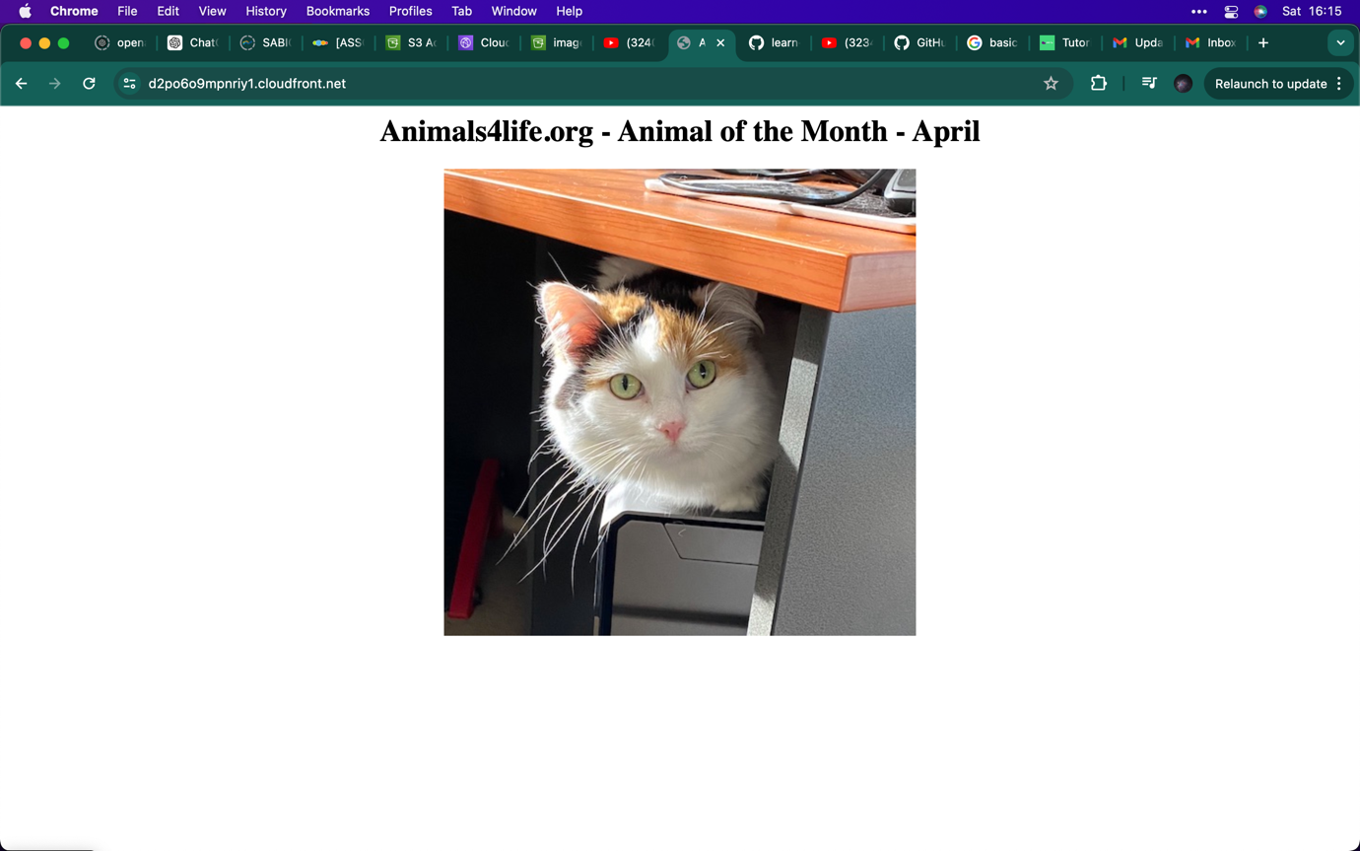

1. This is the image from the index.html page.

Note: all of these images and contact was retrieved from S3 bucket

**Final – make sure you delete the bucket in the S3**